**AI Planning with Python**

**AI Python Libraries:**

1. **Scikit - Learn**:

This Python library supports both supervised as well as unsupervised ML. Has a broad range of features and it can interoperate with numeric and scientific libraries of Python like NumPy and SciPy. List of AI features:

* Clustering, regression and classification algorithms
* DBSCAN, gradient boosting, random forests, vector machines, and k-means
* Reduction of dimensionality
* Decision tree pruning & induction
* Decision boundary learning
* Feature analysis & selection
* Outlier detection & rejection
* Advanced probability modeling
* Unsupervised classification & clustering

1. **NumPy:**

Comes with functions for dealing with complex mathematical operations like linear algebra, Fourier transformation, random number and features that work with matrices and n-arrays in Python. NumPy Python package also performs scientific computations.

1. **TensorFlow:**

Can handle deep neural networks for image recognition, handwritten digit classification, recurrent neural networks, NLP (Natural Language Processing), word embedding and PDE (Partial Differential Equation). TensorFlow Python ensures excellent architecture support to allow easy computation deployments across a wide range of platforms, including desktops, servers, and mobile devices. Major abstraction benefit - allows users to focus on the comprehensive logic of the app instead of dealing with the algorithms itself

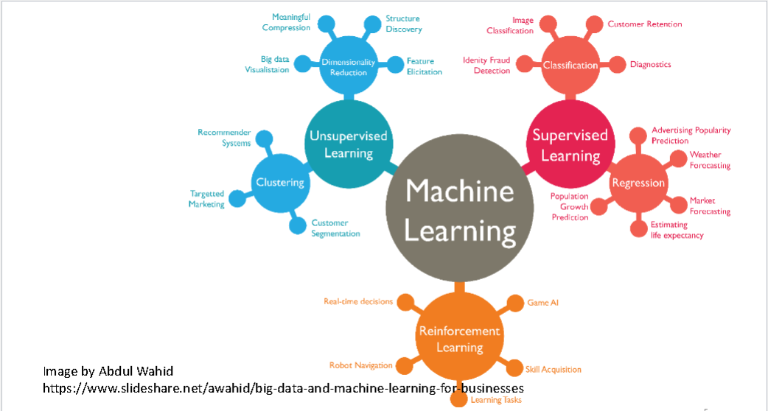**AI models:**

**Overview:**

App will consider users past behavior and past preferences, in-app activity and, based on this data, will offer only the most relevant animals in the feed or potential matches.

**Regression (supervised):**

Using linear or logistic regression to find the best linear model or weight of use data, like attribute searches and past matches.

**Dimensionality Reduction (unsupervised):**

Gathering data on attributes and reducing dimensionality to collapse attributes into one. Faster data analysis, easier to implement.

**Clustering (unsupervised):**

Clustering user with same searches and preferences into groups and giving it a label to each. For example, User1 = <long fur, young animal, breed> pet= <dog> , User2 = <short fur, young animal, breed> pet= <cat>.